Title of the paper
in Times New Roman 16pt bold, centered
First Author^{1,*} (Presenter underlined), Second Author², Third Author, Forth Author… (Times New Roman 12pt bold)
¹ First Organization address
² Second Organization address
*Contact Email: first.author@organization.org
Introduction / Abstract (Times New Roman 12pt bold)
Regular text should be written in Times New Roman 11pt. The line spacing is to be 1.0. Make sure your text is fully justified.
Use a space of 4pt between paragraphs and a space of 6pt after and 18pt before headings.
1. Format (a space of 6pt after and 18pt before headings)
Please use A4 format with 3,0 cm for margin (top/bottom/left/right). Please do not use page numbers.
2. Figures, Images and Captions
Figures and Images should be centered and located within paper margins. Figure and image captions should be centered below, font size 9pt.

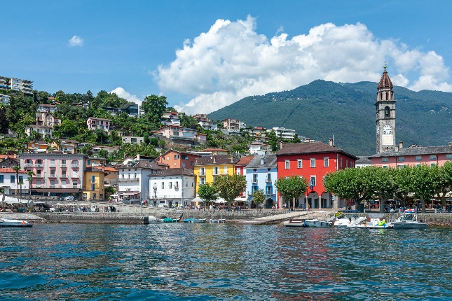
Fig. 1: Monte Verità awaits you!
3. References
Use a font size of 9pt, line-spacing 1.0, justified and a space of 4pt between to references. Please use sequential numbers enclosed square brackets. The suggested style is given below.
4. Number of pages
The maximum is 2 pages.

References

[1] J. Faist, F. Capasso, D. L. Sivco, C. Sirtori, A. L. Hutchinson, and A. Y. Cho, “Quantum cascade laser,” Science 264, 553 (1994).

